**Conversation Guide: Digital Health Modernization Discovery Research - Caregiver Group**

**Bold text identify the moderator’s questions.**

*Text in italics are Jen’s observations and interpretations of the participant.*

[Text in brackets are interpretations in participants’ direct quote.]

**Background (5 minutes)**

To get started, I’d like to get a little background information about you, and your experience with the VA.

1. **Can you tell me a little bit about yourself and the Veteran you care for?**

I guess in that regard my situation is a little different. Most people have been married to their spouses prior to the injury occurring. I met my husband a year and half after he came back from deployment when we were stationed together in Virginia.

A few weeks, months after dating, once we started spending more time together I started noticing there were some behaviors that weren’t quite normal. Stuff he would be sitting down and we would be watching something on Netflix and he check out for a while. Or he would fall asleep when we were watching tv and would start having really bad almost night terrors but not at night. And would have to take a hot shower to cool off.

I realized that was not behaviors indicative of something that was a good thing. So I encouraged him to get it checked out after he had mentioned that when he was on deployment he was part of a group on a break from a mission and there was a recoilless rifle blast and he was within range of the blast.

When they did the screening there wasn’t anything, he hadn’t lost any limbs so they left it at that and never did any follow up PTSD screenings or to check if there was any traumatic brain injury.

They told him if he had problems the people in his next duty station would take care of it. Which is kind of strange because people at your next duty station aren’t going to know how you were behaving prior to that injury. So it was a weird position to get put in.

After I encouraged him to go to his PCM that’s when he started to get treatment at Fort Belvoir and going through therapy.

The caregiving situation happened early on in our relationship and I guess I kind of knew what I was getting myself into when coming into all of that. Instead of being in a relationship over a long term then having something happen.

I never saw him any other way aside from post injury.

**Veteran as well:**

Yes, once he started going through therapy there were some treatments that went wrong and exacerbated certain conditions. So instead of being able to stay in, which was the hope for both of us, I ended up getting out to become a full-time caregiver and he ended ups having to get medically retired.

**When did that happen:**

Within the same year. I got out in May 2017 and he was med boarded in December 2017.

**Where are you and what does your free time look like:**

*Participant laughs.* A little different now because of COVID.

We are outside of DC in the Maryland side. Right by the University of Maryland.

Free time used to be lots of kind of causal exploring and hiking with our two dogs. We used to do more adventruing, like long drives and stopping at brewerys and grabbing fun food. Obviously a lot of that has been squashed. Most of our dog walking adventures are around the house and then back. Free time is mostly done indoors outside of that. Some video games, and we are getting back to renovating our house. So when we was moved up to Walter Reed every thing here is insanely expensive so the only real option aside from renting is buying a fixer upper. So a lot of time is spent fixing up the house and learning to how to fix things in the house.

1. **When did you step into the role of a caregiver?**

2017

**When did you start dating and do this on non-full time basis:**

We met in 2014 over the summer and probably started dating the end of August or beginning of September. I think it wasn’t until a few months later for us to have the conversation that it is going somewhere. And because it was going somewhere I am noticing some things and if we are staying together long term I think you need to get some help. Because zoning out and having night terrors isn’t normal behavior and needs to be checked out. And then hearing stories about his deployment, those were all things that were ringers that needs to be looked at a little closely. Especially stuff regarding the unit he was deployed with raised some red flags for me.

**What’s his name and is he your partner or husband:**

He’s my husband and his name is Seldon.

1. **Do you personally receive any benefits from the VA?**

Yes, I also receive my care through the VA.

**When you say care you mean health care:**

Yes.

**Other benefits:**

Disability yes.

3**.a. What VA benefits does [Veteran] receive?**

He is 100 percent.

He was using his GI bill until COVID. That is on hold because it doesn’t make sense to use a GI bill for online classes. He is going to school at the at the community college until UMD campus opens back up.

**Are you part of the caregiver program:**

No but I am recognized as his caregiver. He doesn’t even know he has seizures and pretty much can’t be left home alone.

I have applied for the program three times prior to the updates to the program, and most recently I have had the social worker and therapist tell me I need to reapply because of his difficulties and I am home with him 24/7.

Most recently I was denied over the summer. I did the whole appeal process and was denied all the way up to the highest level.

**Can you tell me about that experience for applying and going through the appeal process:**

It is a bit disheartening, not so much for me, but mostly for him as a veteran. I think in a sense he was a lot angrier about it than I was.

I was looking for assistance mostly because I don’t have formal caregiver training so I was hoping that would be helpful to have access to. I am fully aware that caregiver burnout is like a real thing. From that aspect assistance would be helpful.

The fact that there’s this group of people that look at his medical records and have never met him and have never seen his situation are saying that he isn’t broken enough to need someone to take care of you.

I am just like come hangout at my house for a week and I will show you. I have to cancel meetings and cannot do stuff because my husband can’t find something he’ll have a seizure. He’ll be in the kitchen alone because he will forget about boiling water and the pan will burn. I have to do the stuff in the kind, and all of the basic stuff like that. And I am also have to be in charge of his medication.

I know there is a lot more to the caregiver program that it is tricky how you word things. You have to say my veteran would be homeless or institutionalized if I weren’t around. Which is pretty much the case.

So I think it mostly upset him and hurt his feelings. Like what other situation does he need to be in. He obviously doesn’t have any limbs missing, but his short term memory is shot and he’s in pain from seizing everyday. That sucks just as much.

So there is lack of validation for him which is a little unfortunate.

Last time I tried to apply without saying anything. It is hard for him not to know about me filling it out because his care team has to be in the loop when filling it out.

It is annoying to have to refill out the paperwork.

1. **Are you claimed on [Veteran] benefits or vice versa?**

I am on his.

**The social worker and therapist encouraged you to apply to the caregiver program, but you mentioned some assistance and training:**

Yes.

**Some respite, tips tools for caregiver burnout:**

Yes.

1. **Do you manage any of [Veteran's] VA health care online?**

Yes. I handle all of the medication refills, any correspondence with doctors. If he needs to get referrals or any kind of messaging.

I handle all of secure messaging stuff because he will see that he has a notice that he has a secure message from the VA, but that doesn’t mean he clicked through to My HealtheVet to read it or respond to it.

I handle all of that then managing appointments.

**Do you use My HealtheVet to manage your own healthcare?**

I do, yes.

**What’s it like managing both of your healthcare. Do you have different accounts:**

Yes, they are completely separate accounts since we are both enrolled or receive the healthcare benefits from our own service.

So I have the login saved separately. Having to remember extra passwords can be a pain in the butt. Most of the time I use his laptop to login and do all of his stuff because it is easier.

When I do his medication refills as soon as we’re done with the appointments I go in and request everything. Especially with how the mail has been lately. I don’t wait until we’re 2 weeks out. I just go an hit refill everything. I would rather have it a little early so I can prep it and have it ready to go.

That’s how I handle my stuff too.

**Do you use any other websites or online tools to manage VA benefits:**

I use ebenefits every once in a while. Mostly to just get documentation but I also have a lot of that saved in my Dropbox and Google Drive for both of us. That’s about it.

I am on my HealtheVet more than anything.

**So you said you use ebenefits for documents. Can you give me a use case when you would need certain records or documents:**

So a lot of the caregiver support program applications, not through the VA, like the non-profits groups. You need to provide proof of discharge and proof of disability. That kind of thing. Typically it is easiest to go and download the base letter that says he is at 100 percent and medically retired for PTSD.

**Sounds like you’re getting some outside caregiver support:**

I am plugged into a few groups.

I am actually a program coordinator myself now for Yellow Ribbon Fund based out of Walter Reed. But they have chapters all over the country.

I actually plan the health and wellness, and respite for caregivers in the DAV. I just took that on in September and that has been helpful for me. Part of the application to be recognized as caregiver, you have to submit DD-2-14 to prove that you are a caregiver. You don’t have to be a VA level caregiver because they understand that half of the reason people reach out for support because it is so hard to get into the VA caregiver program.

1. **Do you use any mobile apps to manage [Veteran's] health?**

I don’t use any of them. *Participant chuckles.* Mostly because the fact they are individual apps for everything and the concept of having to download individual apps for everything was not appealing.

*Participant laughs.*

It was easier to pull it up on a browser to do it on mobile instead of apps.

1. **Are there any apps you are thinking of when you say individual apps:**

I did a trial run or a study thing like a year ago and it was running through the different apps that the VA had to offer. And it has been so long I don’t remember what they are.

I’m going to try to pull up the list now because I don’t remember what they all are.

**Where is this list saved? Where are you looking for it:**

So it’s on the Department of Veterans Affairs, they have like a VA app store.

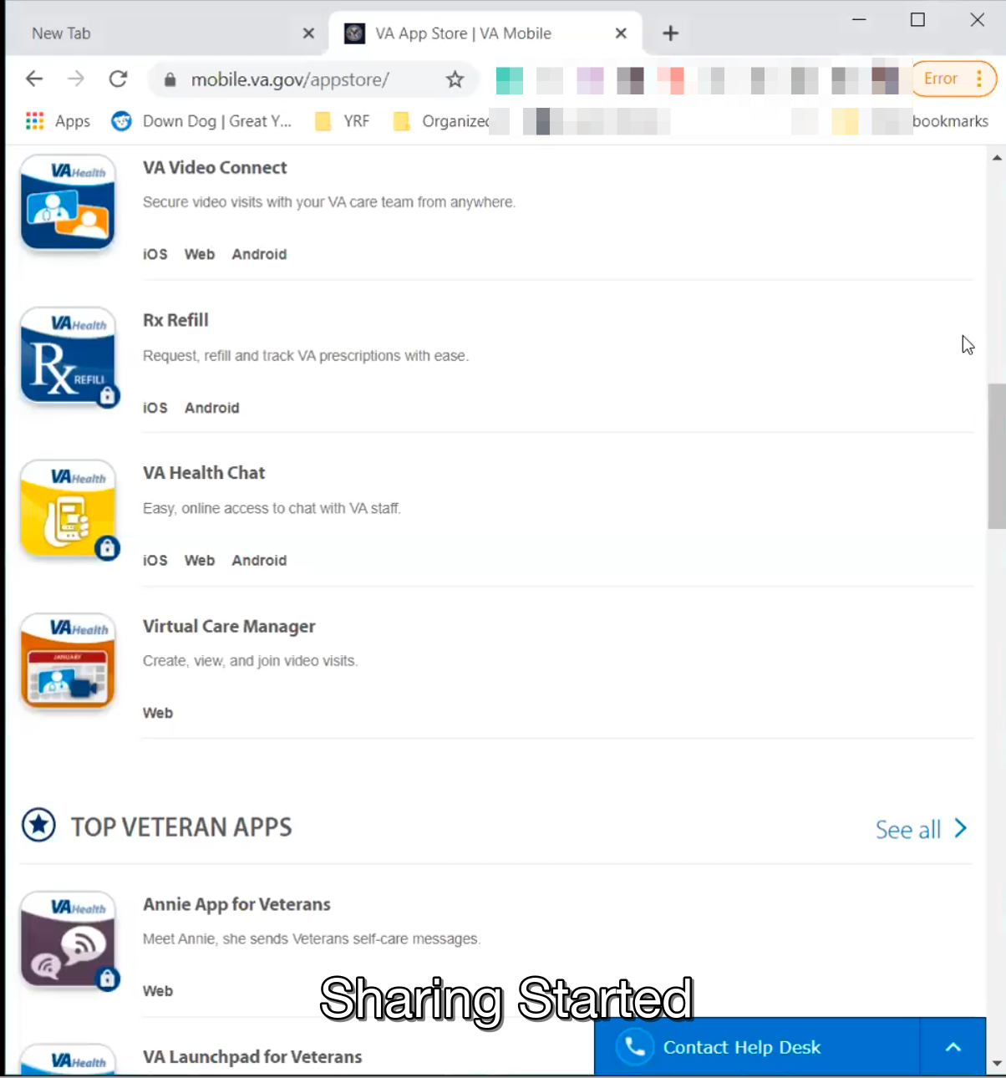

*Participant shares screen of [mobile.va.gov](http://mobile.va.gov)/app-store/ site on Chrome browser in laptop.*

So like these are all very great but the fact there are individual apps for everything is super exhausting. I have a lot on my phone and I don’t want a whole folder of VA apps. *Participant laughs.*

As great as some of them are, and I appreciate the mindfulness apps. I have down dog yoga app on my phone and computer so I am not going to go out of my way to download another mindfulness app. I could see why that one would be helpful.

But all these other ones. It is just so much. And then the concept of having another app to launch all of the apps from. *Participant laughs.*

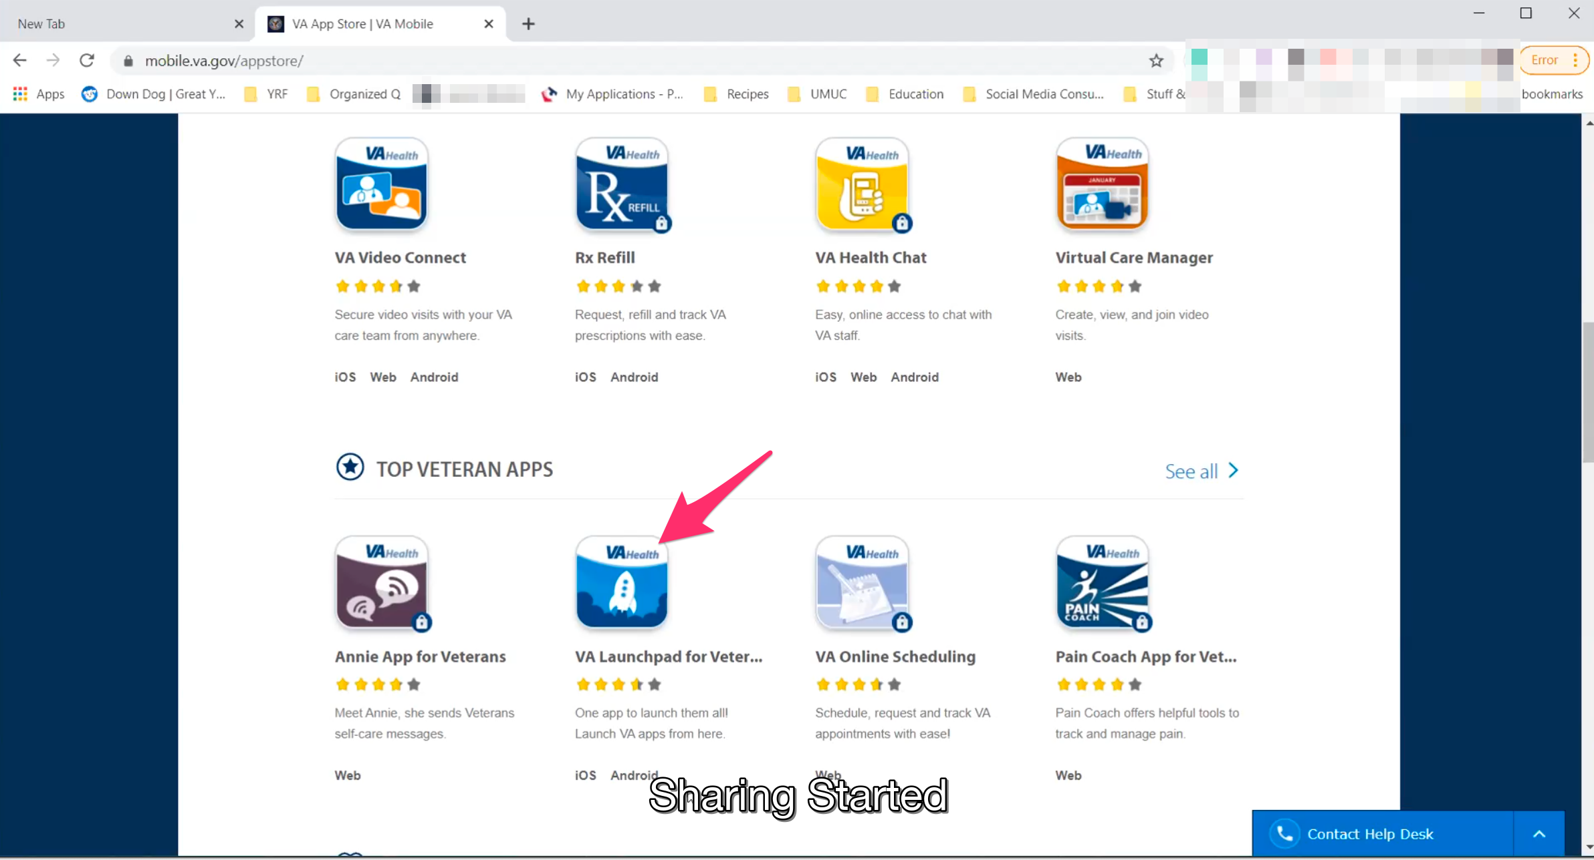

*Participant is seemingly referring to VA Launchpad app.*

I remember looking at that and thinking that’s just a conundrum in and of itself.

It would be nice if you only needed one or two of the things, but it would be much better if all in one app location. That’s why I just use the browser, because this is too much.

If I downloaded this on [Veterans] phone he would be super overwhelmed.

**You said you were in a testing phase or a study. Was that through the VA:**

Yes, I am pretty sure it was.

**What did you do as part of that:**

I gave them similar feedback. They showed me all the apps, and I told them its good stuff but it is overwhelming.

First of all, the older generation has a hard enough time to begin with apps and you’re giving them 30 billion apps to choose from. And that’s going to make it really difficult.

And then you have the younger generation that love apps, but that doesn’t mean they want a bunch of them for their healthcare for their phone.

Then people like my husband who have conversion disorder, or brain trauma, trying to remember or handle and process this is going to be super difficult. There is a lot to expect from them.

**Does he use apps for his treatment or any therapies:**

Not really. All of his appointments are generally done, right now anyway, on telehealth. So he waits for the emails and he logs on and does everything on the laptop. That’s about it.

**Mental model of health at the VA (20 minutes)**

Now I’d like to hear about your experience first learning about VA benefits. **(10 minutes)**

1. **How did you learn about the health care available to [Veteran] through the VA, and what was the process of applying for and accessing those benefits?**

We had to figure out a lot of it ourselves to be honest. *Participant laughs*.

We didn’t even know the caregiver program was a thing until we were both out of the military for a few months. All of that stuff took awhile to get plugged into once he was retired.

You think there would be someone walking you through it telling here’s what’s going to happen and how it works. There was a lot more, hey figure it out on your own. Here is a general idea. Here’s a piece paper you might have to log in and figure this stuff out.

As much as it sucked that I got out first, because it wasn’t in either of our game plan, but I was glad I was able to get out a few months ahead fo him I was able to navigate the things.

Once he was medically retired we turned around and he had his first medical appointment at the VA the day after he retired. People at the VA were like, wow no one ever does this. And I was like, well, we need help so we couldn’t just sit here and waste time.

I had a few months to kind of fumble around and check things out and go through the system before he had to be fully immersed in it which was helpful.

But I know that’s not the case for everyone. Not everyone is dual military couple or has dual access to it. Trying to navigate it while you’re on your way out the door can get really confusing.

Plus even just learning to login, when they give you 30 different ways to verify yourself. I appreciate it because everyone has different ways of doing it. But I am sure it is hard as a caregiver to try to log in to your husbands computer, there is the [ID.me](http://ID.me) and the verify, and all those four other options. And then at the bottom is the sign in option. I can imagine that if you are not used to using military or DoD websites it could be hard looking at it from an outside perspective.

**Because you had exposure to government websites gave more context:**

Yeah.

**What do you mean by dual access to this stuff. Can you say more about that:**

I meant that as us both having our won accounts. And then also the fact that I guess we both have our logins.

Then the fact that I do have my husbands permission to login to his stuff

I know as a caregiver that can get kind of tricky because you have to login into order to manage the medication or appointments.

If you are or aren’t a VA recognized caregiver you don’t get a special login that connects to your veteran’s account. You just have to hope they haven’t changed their passwords or gotten locked out of the account.

You have to use their logins, which I think in most cases it is typically frowned upon up.

Because even up until recently, when I was emailing [Veteran’s] doctors his psychiatrist was weird about me reaching out until he had a bad episode. And then they told me I could reach out anytime. I asked what changed, the only way I have to contact them is through his secure messaging. It’s not like I can pull up my own Gmail and send you a note.

I think there is a stigma with the providers, which I totally understand. Because you don’t want spouses just getting on there and flying off the handle at providers for unnecessary stuff.

But at the same time the caregivers need to access their husband’s stuff.

If there is a way to create a separate login with the same permissions without making you feel like you’re the parent logging into the kids computer. That’s sometimes how I feel.

It could be more like hey were working together on this and let me double check that the medication is refilled and appointments are schedule. That way as a caregiver you can fulfill your responsibilities without stepping on your spouses toes.

**Thinking about what it might it look like having a separate login. What do you wish that might look like:**

Obviously not much would change as much as I get into the account, it would just me being recognized as a second user on the account.

Something that notes me as a spouse/caregiver so if I have to reach out to the providers or reschedule an appointment they know it is something I am doing in the system and that it is not coming from him.

Possibly that way in case if he has an episode, or something happens, and he decides he doesn’t want all the appointments and goes and cancels everything. I could go in and reschedule all these and then you could clearly you’d see it was his account not mine. That would be a quick example. Here is an example, I am responsible for this stuff and why I need access to manage it.

**One aspect it being able to identify to the provider with secure messaging who is doing what, but also for the prescription refills and appointments. It would be valuable to know which user was doing what:**

Yes for sure.

**Except to have all access to what he sees:**

Yeah I cant think of anything on there that is super secure or private. I can’t think of anything, I wouldn’t want my significant other to see, it is all in the open.

Maybe if the home page for the caregiver was a calendar. I guess. Since we’re spitballing. Just because you know I have a shared calendar with him so I use that to manage our appointments. And then I have to double check it with everything on My HealtheVet. And then I have to go through our accounts then go through his email to make sure we have all of the Zoom links and any other outside provider referrals are in the calendar.

As a caregiver since those are a big part of the responsibility is making sure the person you are caring for is making it to appointments. Having a calendar with appointment and medication reminders would be a big helper, a big focus of the caregiver side.

Other than all of that information I don’t see a need to reinvent the wheel a whole lot.

**Expect to be able to manage your personal health care needs in the same account or expect it to be separate:**

I think that might get tricky so I am okay with it staying separate. Only because I think they are two different profiles and they are setup under the VA separately. I think that’s ok to have them separate.

If they find a way to merge them that’s cool but looking from it for a regular caregiver perspective. I know there is a lot of dual military couples where one is the caregiver but we are still in the minority.

1. **When it comes to [Veteran’s] healthcare what’s the most important thing you need from the VA:**

*Participant considers this question for several seconds.*

I would think it would be a toss up between timely responses with secure messaging and just making sure medication is shipped on time are the two biggest things.

Some of those meds are for mental health and I can only do so much if I order them as far in advance as it will let me and they still don’t show up on time. It is really important.

I know secure messaging tells you that the provider will get back to you in 24-72 hours. But if that is the best way to contact the provider, and if messages are urgent, then maybe there is a way to improve the turn around time on that.

**What would that look like to indicate something needed faster attention:**

Maybe if the drop down menu options, currently they are pretty generic.

The subjects are generic. Maybe if there were a way to notate. I guess this is where it gets is tricky because everyone’s perception of urgent or mental health issues vary.

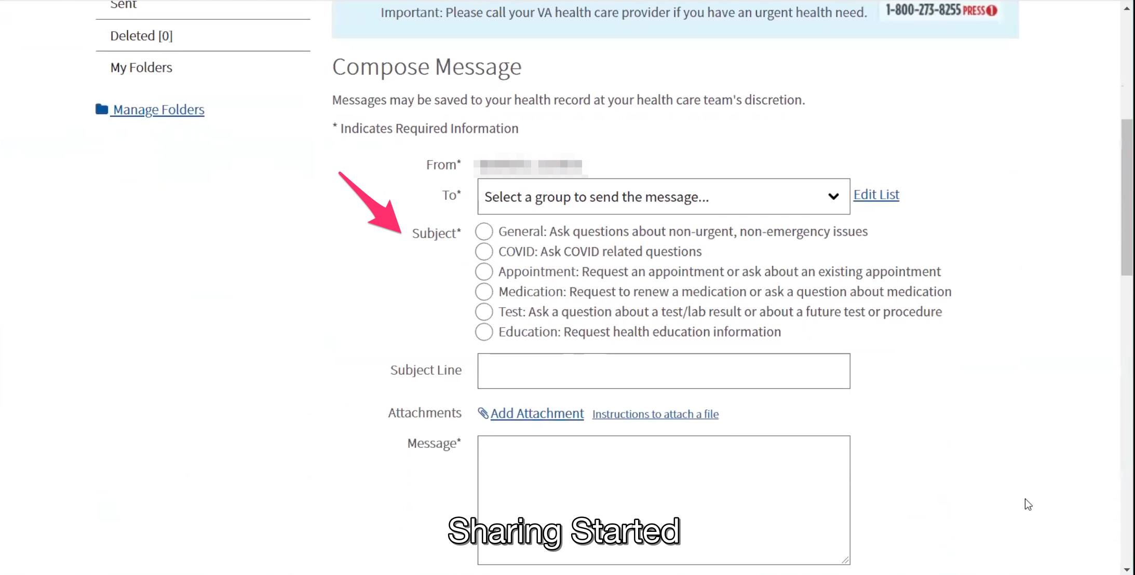

*Participant shows Compose Message page for Secure Messaging. Points out the radio button options for “Subject” field.*

But having a way to be like hey this is a more timely or urgent matter, here’s what’s going on.

Notating that it is caregiver PTSD related or referring to an episode or a seizure or issue in the dropdown for - I don’t want to say caregiver related needs, because it might sound like you are catering to the caregiver. But the providers probably won’t like that.

But like something that notes more urgency and that it is coming from someone who is concerned with the wellbeing of the veteran with out it being an 911 emergency. Like if medication is low and you can’t get ahold of the pharmacy.

I know a lot of caregivers that are in rural areas and were isolated pre-COVID and now even more. When it comes to them needing to get prescription refills or needing to reach out to the providers. They are the ones that will need this more then this of us that can go 15 minutes down the road and go to the VA and show up at the pharmacy desk to get it.

**If there is a need to** r**each out to a provider, you’d want to be able to convey it’s from you and it’s urgent, and maybe related to something specific like a mental health condition:**

Yes. Then maybe, I know it is tricky with the “To:" the drop down because it is for who you currently seeing or you have referrals to.

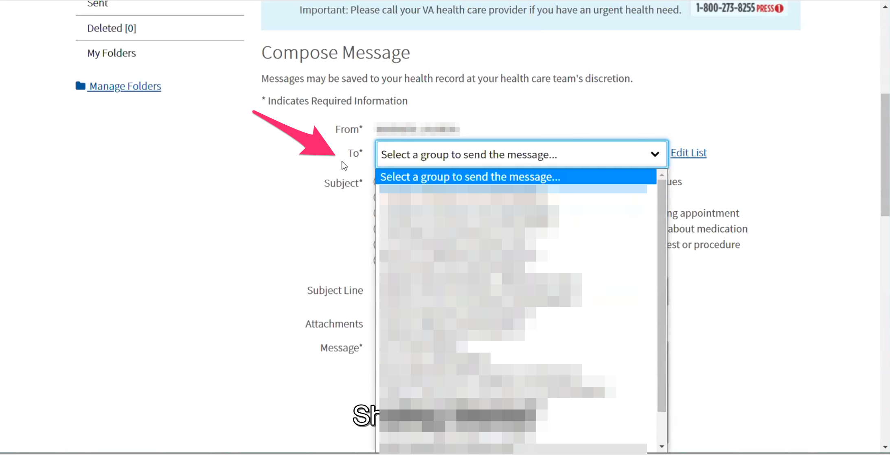

*Participant points out “To:” drop down field on Compose Message page.*

With the hypothetical caregiver profile if there is a way to give the caregiver direct access to the whole clinic, like that nurse case manager filters everything. I know that is part of the turn around time. The nurse case managers read everything then send it to the doctors. If there is a way to skip that middleman that is part of what takes so long.

The more urgent messages sent directly to the doctors for stuff like this would also help with the turn around time and cut out some of the lag.

I know most of the the staff is really helpful but I have also seen a lot of them just sit at their desks and not all of them are helpful. So the efficiency level varies. *Participant laughs.*

Now I’d like to ask you how you manage information and tasks related to [Veteran's] health care. For each one, talk me through the steps you’d take. If there is something that you go online to complete, I may ask you to share your screen so I can see what you would do. **(10 minutes)**

**Tasks** Moderator should prompt about device usage if participant mentions digital tools or resources.

* **How would you reach out to [Veteran's] VA care team if you had an urgent need?**

Depending on what it is, I have the direct number for his trauma therapist who he sees every week. So if it is not medication related we can very easily reach out to him.

However if it is medication related or outside of the therapy spectrum, it is tricky.

I have had issues before where I have been on hold for 1-2 hours and they are like if you have a problem just call the patient care advocate. And you call the patient care advocate and they tell you to leave a message because no one is available, and they get back to me 2 or 3 weeks later. Well you can’t help because the problem was two weeks ago so there’s no real way to follow up.

I have not had good experience with the patient care advocate route as a way to solve problems. So I try to reach out to the provider directly when I can. First of all they can give me an exact answer and be the most helpful because they are knowledgeable for what we need.

And if not then he has a social worker through the VA that is pretty good at answering emails or calls. So if I don’t hear back from the doctors then I circle back with the social worker.

* **How do you make appointments for [Veteran]:**

With his therapy we are on a regular schedule and he is on the calendar each week so we just confirm the appointment at the end of the current appointment.

If something needs to change we come up with a plan right then and reschedule or he will give us a call.

Pretty much everything else is in place because we schedule at the end of a previous appointment or we just wait we’ve cleared with the clinic for a follow-up. So we just wait for the front desk to give us call then I handle the scheduling.

* **Have you used appointments through myhealthevet:**

Umm, I have tried to.

I know that for me I don’t think I had the option to do a lot of it online. I remember going in because they advertise it on the front of the website. You can schedule you appointments online. I was like that would be great so I don’t have to bug anybody or sit on the phone. But when I went on to do online, it only gave you an option to schedule appointments in a nominal amount of clinics and none of them were what I needed. So it wasn’t helpful, but I know how to use it.

* **Wasn’t showing you the locations needed:**

I think the issue was that it didn’t have the clinic that I needed.

* **That was for your healthcare:**

Yeah. I don’t think I had anything to schedule for him at the time and I just wanted a feel for how the system works. I know it is there as an option.

**Thank you and closing (2 minutes)**

**Feedback**:

Not right now. But I am also more than happy to share more thoughts on this stuff. I don’t mind. Participant laughs. My goal is to make this easier for more caregivers as they come along. Anything I can do to help or answer more questions I am helping to do.